**CERTIFICATE** 

Maharshtra State Board Of Technical Education, Mumbai

GOVERNMENT POLYTECHNICS, SOLAPUR

**Subject: Object oriented programming (22014)**

***Topic :- Text editor***

**Guide: Sathe sir.**

Submitted by:

|  |  |
| --- | --- |
| **Roll No.** | **Name** |
| 76 | Sufiyan Sajid Shaikh |

Of third semester of diploma in Computer in Technology of institute **Government** **Polytechnic, Solapur (0015)** have completed the micro project work satisfactorily under the guidance of **Sathe sir** in the academic year 2019-2020 as prescribed in the I-Scheme curriculum

Project guide H.O.D Principal

**Sathe sir.**

Acknowledgement

We wish to express our profound and sincere gratitude to our guide **Sathe sir**, who guided us in the structure of micro project as well as some main points in that micro project also they cleared our all doubts about micro project .We are Indebted to his constant encouragement, co-operation and help .It was his enthusiastic support that helped us in overcoming various obstacles in the project.

We would also like to express our thankfulness to our beloved Principal as well as HOD and other faculty members of our second year department for extending their support and motivation

Finally, we completed our micro project that regarding to our syllabus as well as department, Once more thanks for all Group members, Respected **Sathe sir, Principal, HOD** and other Faculty Members who helped us in the micro project completion.

Thanks!!

**PART A – Micro-Project Proposal**

**Text Editor**

**1.0 Brief Introduction**

The micro-project includes the a Text editor based on object oriented programming concepts using C++ language

**2.0 Aim of the Micro-Project** (in about 1 to 2 Sentences)

This Micro-Project aims at:

The aim of the project is to develop the skill of creating or developing Mini Project using concepts of OOP. The aim of this Micro Project is to develop programs using C++ language.

**3.0 Intended Course Outcomes**

1. Develop/Use functions in C Programs for modular programming approach.
2. Use of various header files and their functions.

**4.0 Literature Review**

We searched information for the suggest topic. Collected the data required for the micro -project.

**5.0 Proposed Methodology**

1. First searched for the suggested micro-project.
2. Collected information for the suggested topic.
3. Started for the micro-project.
4. Completed micro-project.
5. Showed to respected teacher.
6. Teacher regarded of some changes.
7. Done the changes into the project as told by teacher.

**6.0 Resources Required.**

|  |  |  |  |  |
| --- | --- | --- | --- | --- |
| **S. No.** | **Name of Resource/material** | **Specifications** | **Qty** | **Remarks** |
|  | Laptop / PC | Windows 7 ultimate / Windows 10 | 1 | - |
|  | Geeksforgeeks | Website | 1 | - |

**7.0 Action Plan** (Sequence and time required for major activities for 8 Weeks)

|  |  |  |  |  |
| --- | --- | --- | --- | --- |
| **S. No.** | **Details of activity** | **Planned Start date** | **Planned Finish date** | **Name of Responsible Team Members** |
|  | Searched for topic of micro-project | 20/10/2020 | 24/10/2019 |  |
|  | Topic searched:-   1. Booking system 2. Hotel Management 3. Text editor | 24/10/2020 | 24/10/2020 |  |
|  | Discussed with teacher about the topic | 3/11/2020 | 4/11/2020 |  |
|  | Teacher approved for Library | 4/11/2020 | 5/11/2020 |  |
|  | Created prototype of our project | 12/11/2020 | 15/11/2020 |  |
|  | Started for developing the webpage | 21/11/2020 | 22/11/2020 |  |
|  | Created a total of 15 webpages | 28/11/2020 | 31/11/2020 |  |
|  | Linked each of the pages to each other also to index page | 1/12/2020 | 2/12/2020 |  |
|  | Completed the total website | 15/12/2020 | 16/12/2020 |  |
|  | Showed website to teacher and she suggested some corrections | 17/12/2020 | 18/12/2020 |  |
|  | We made the suggested correction | 19/12/2020 | 20/12/2020 |  |
|  | Teacher approved the website | 22/12/2020 | 23/12/2020 |  |

|  |  |  |
| --- | --- | --- |
| Sr. No. | Title | Page no. |
| 1 | Introduction |  |
| 2 | Aim |  |
| 3 | Advantages |  |
| 4 | Course Outcome |  |
| 5 | Actual Methodology |  |
| 6 | Resource |  |
| 7 | Source Code |  |
| 8 | Output |  |
| 9 | Skill Developed |  |
| 10 | Application |  |
| 11 | Area of Future |  |
| 12 | Reference |  |
| 13 | Conclusion |  |

INDEX

INTRODUCTION

In This Micro-project I developed a text editor based on concepts of object-oriented programming. I used concept like classes and object with inheritance and file handling. Text editor can create files, write into them and also open a existing file to view and edit.

AIM

* The aim was to apply concepts of object-oriented programming.
* Use C++ language to code the program.
* Use classes and objects.

ADVANTAGES

* Concepts of classes makes data privacy.
* Use of file class makes it easy to handle files.

Course Outcomes

* Develop flowchart and algorithm to solve problems logically.
* Develop “C” programs using control structure.
* Develop “C” programs using array and structure.
* Develop/Use function in C programs for modularprogrammming approach.

Actual Methodology

* First searched for the suggested Micro-project.
* Collected information for the suggested topic.
* Started the Micro-project.
* Completed Micro-project.
* Showed to respected teacher.
* Submitted the Micro-project.

RESOURCE

1. Software-Turbo C++
2. Visual Studio Code.
3. Windows 10 Home.
4. Geeksforgeeks.com (To learn Some File Handling Concepts).
5. YouTube: Some programming/File Handling Tutorials.

Source Code of Project

#include<iostream>

#include<string>

#include<fstream>

#include<algorithm>

#include<windows.h>

#include<conio.h>

using namespace std;

class TextEditor

{

   string current_directory;

   string file_content;

  protected:

   fstream open_file;

 public:

   TextEditor()

  {

      current_directory=system("cd");

  }

     void OpenFile();

    string DeleteFile(fstream * FILE);

    void edit_file();

};

class Write_into_file

{

    fstream New_File;

      string fileName;

    public:

   Write_into_file(string name)

   {

       fileName=name;

   }

    void fileWrite();

    bool checkFile()

    {

        if(New_File)

        return true;

        else

        return false;

    }

    bool Isempty()

    {

        if(New_File.eof()==0)

        return true;

        else

        return 0;

    }

    void FileRead()

       {

        fstream temp;

        temp.open(fileName,ios::in);

        char output;

         while(!temp.eof())

         {

              temp.get(output);

              cout<<output;

         }

        temp.close();

    }

};

 void TextEditor::OpenFile()

{

    string name;

    cout<<endl<<"enter name of file : ";

     cin>>name;

    open_file.open(name,ios::in);

    system("cls");

    if(!open_file)

    {

        cout<<"ERROR : ' "<<name<<" ' file dosen't exsist "<<endl;

        getch();

        return;

    }

    cout<<"\t\t\t**********"<<name<<"\t**********";

    cout<<endl<<"press  Q/close & return to Home"<<endl<<endl;

    char c;

    while(!open_file.eof())

    {

        open_file.get(c);

        cout<<c;

    }

    c=getch();

}

void Write_into_file::fileWrite()

{

    New_File.open(fileName,ios::out|ios::app);

  system("cls");

  if (!checkFile())

  {

      cout<<"ERROR : cannot open this file";

      getch();

      return;

  }

   system("color 17");

  cout<<"\t\t*****\t"<<fileName<<"\t*********";

  cout<<endl<<"Press Cltr+Z to save & quit"<<endl<<endl;

  FileRead();

  char input;

 input=getchar();

  while(input!=EOF)

 {

    New_File.put(input);

    input=getchar();

 }

  system("cls");

 cout<<"File is saved at directory ";

 getch();

}

int main()

{

int choice;

    do{

        system("cls");

   system("color 07");

cout<<"welcome to NOTEPAD lite Text Editor......\n\n";

    system("cd");

    cout<<endl<<endl;

    cout<<"press 1: create/edit new file"<<endl;

    cout<<"press 2: open file"<<endl;

    cout<<"press 3: delete file"<<endl;

    cout<<"press 0: quit"<<endl;

    cin>>choice;

if (choice==1)

{

     string name;

    cout<<"\nenter file name : ";

    cin>>name;

     Write_into_file Filler(name);

    Filler.fileWrite();

}else if(choice==2)

{

     TextEditor BlindStudio;

    BlindStudio.OpenFile();

}

else if (choice==3)

{

    string name;

    cout<<"enter name of file : ";

    cin>>name;

}

system("cls");

}while(choice!=0);

return 0;

}

OUTPUT

Main Menu

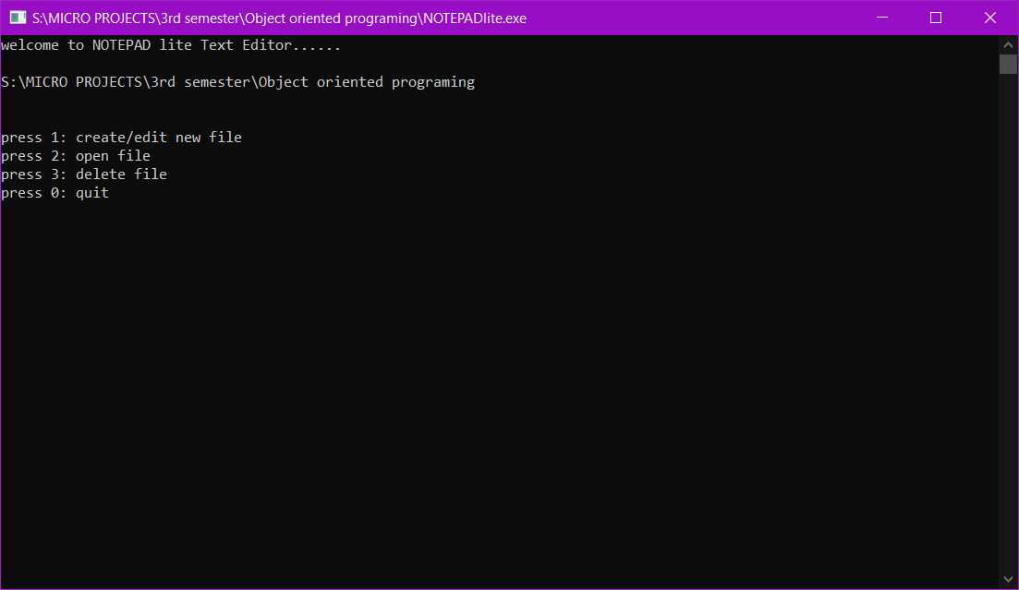

Writing in new file

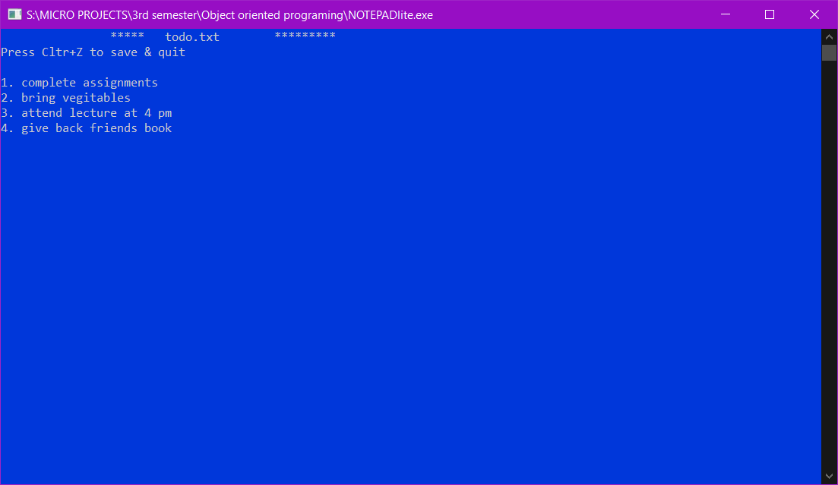

Saving the file

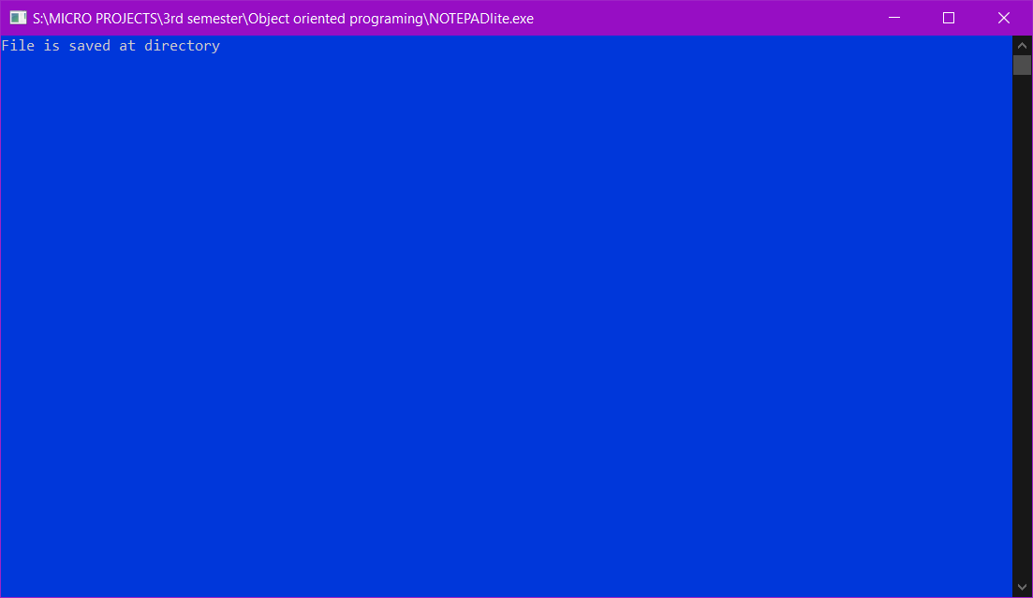

Opening saved file

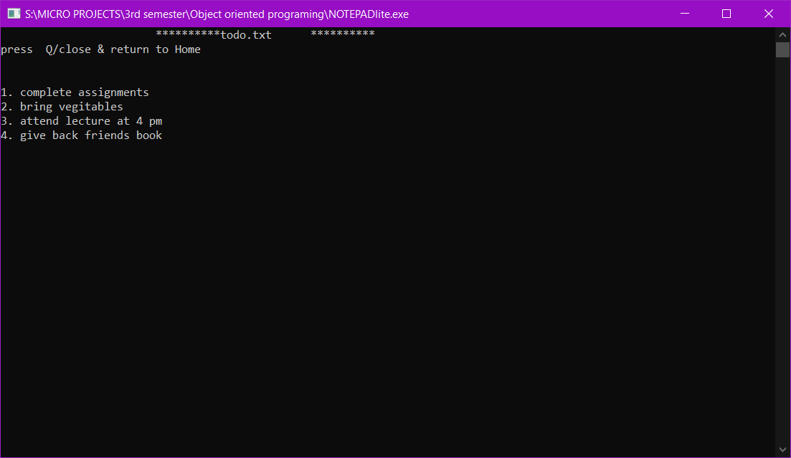

Skill Developed

* I learnt how to make a Simple Project using C++ language.
* I learnt how to use classes and objects
* We got to know different types of function in ‘c’
* From this project we got know that how to create file format in ‘c’ and store information in that.

Application

Application of the micro project is to develop a simple text editor that can edit a text file or create file to write.

Area of future

In the future I will improve its performance and add more functionality like open multiple files, undo, searching and replace world. I will also improve its UI and my it user friendly and easy to use

REFERENCE

This Micro-project was completed under the guidance of our respected subject teacher Sathe sir.

The information of C++ language was also given by the sir and the rest information or Sum video tutorials related to C++ programming was collected through Geeksforgeeks.com website.

|  |  |
| --- | --- |
| Website | <https://www.Geekforgeeks.com/html/> |
| YouTube | <https://www.youtube.com/watch?v=wHFflWvii3M><https://www.youtube.com/watch?v=-G7bJVAIiEI> |

Conclusion

Hence from this Microproject is learnt how to use concepts of object-oriented programming and how they give advantage over procedure-oriented programming. Learnt to Implemented OOP using C++ language